

Report

***Computer Architecture***



**Introduction About The Program**

* To calculate the square value of any given number by the user. Print the given number and square value of the number in front of the given number with the system time.
* Improve the program to with while or for loop to do the above task for 20 times. Print the count before the given number and the square value of it.
* Improve the above program to write above information in to a txt file.
* Improve the above program to read previously saved text file from the hard disk and display the count, Given Number, Square Value and the system time and display again with the current system time.

**Different Technology And Codes Use To Develop Above Program**

* Programming C Language.
* Coding or Programming is the process of creating instructions for computers using programming Languages.

**Source Code**

#include <stdio.h>

#include <stdlib.h>

#include <sys/time.h>

int main()

{

FILE * fp;

int myInt = 5;

fp = fopen("Output.txt","w");

int i;

[

for(i=0; i<20; i++)

{

float x;

printf("Enter number :");

scanf("%f",&x);

float square X = x*x;

[

printf("%d.Square value of %0.2f : %0.3f\n",i+1,x,squareX);

fprintf(fp,"%d.Square value of %0.2f : %0.3f\n",i+1,x,squareX);

time_t rawtime;

struct tm * timeinfo;

[

time ( &rawtime );

timeinfo = localtime ( &rawtime );

printf("Current local time and date : %s\n\n",asctime(timeinfo));

fprintf(fp,"Current local time and date: %s\n\n",asctime(timeinfo));

}

fclose(fp);

system("C:\\Windows\\System32\\ipconfig");

system(“getmac”);

getch();

fprintf(fp,getch());

fclose(fp);

char str[MAXCHAR];

fp = fopen(“Output.txt”, “r”);

if(fp == NULL)

{

Printf(“Could not open file %s”, “Output.txt”);

return 1;

}

While (fgets(str, MAXCHAR, fp) != NULL)

Printf(“%s”, str);

fclose(fp);

return 0;

}

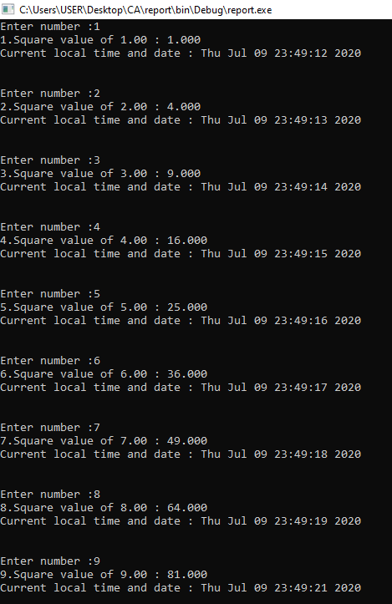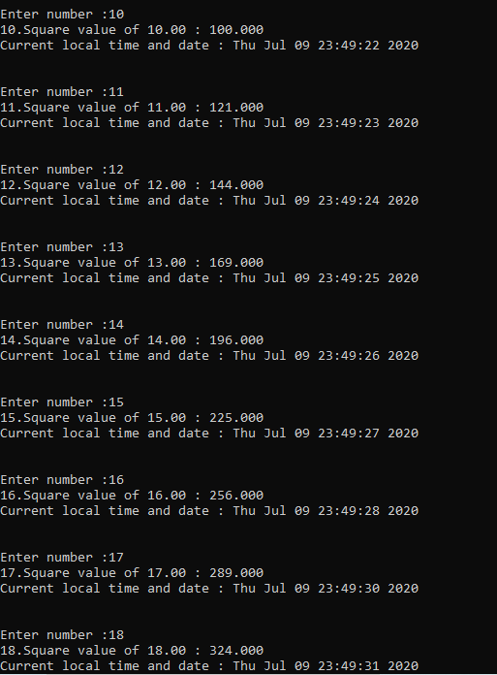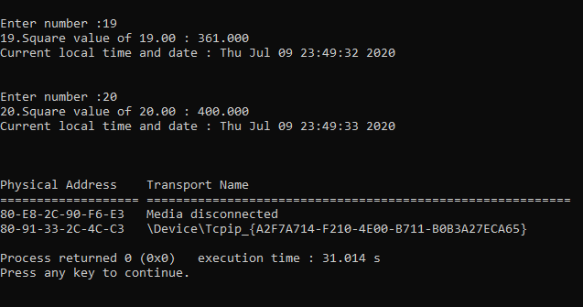

**Output Of Each Program On The Screen**

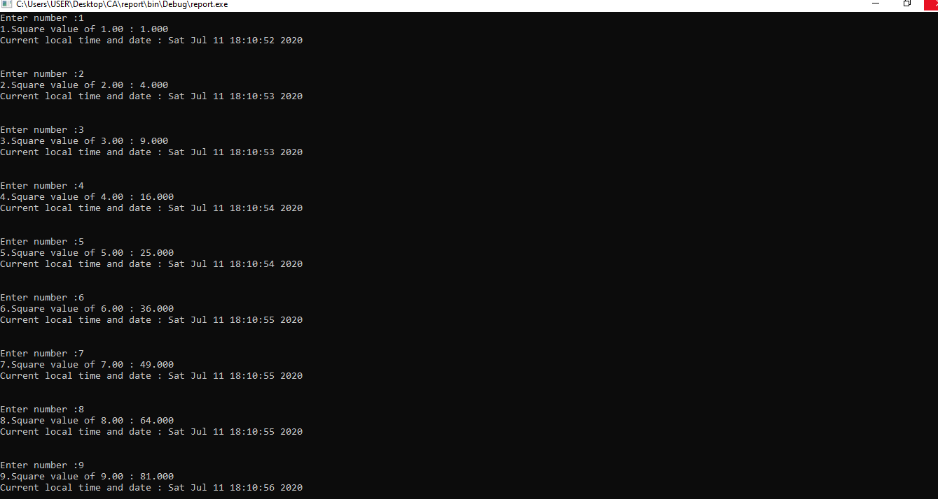

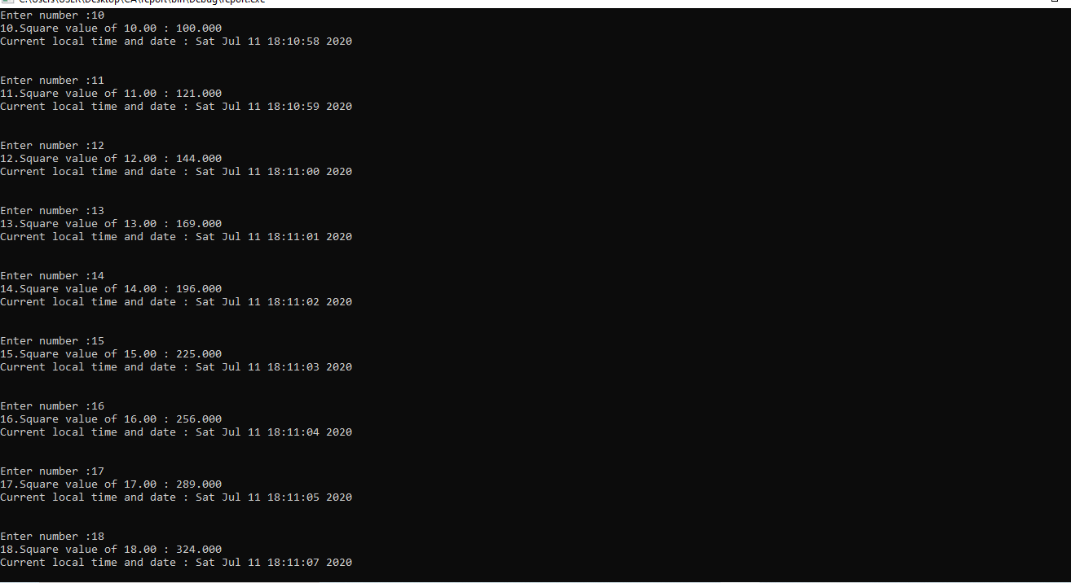

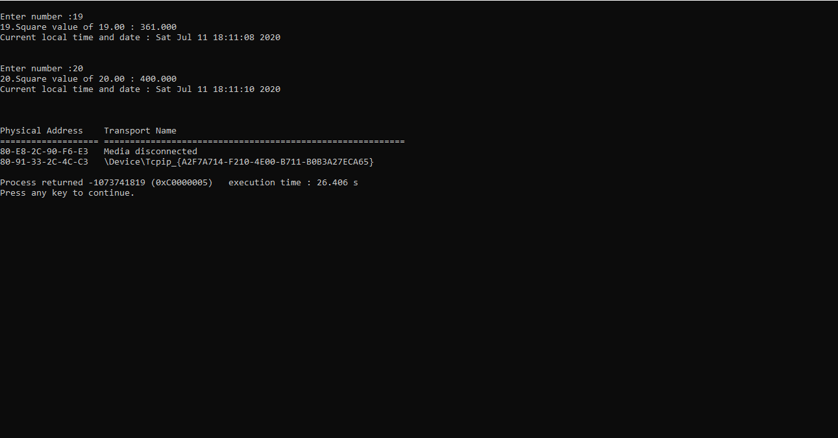

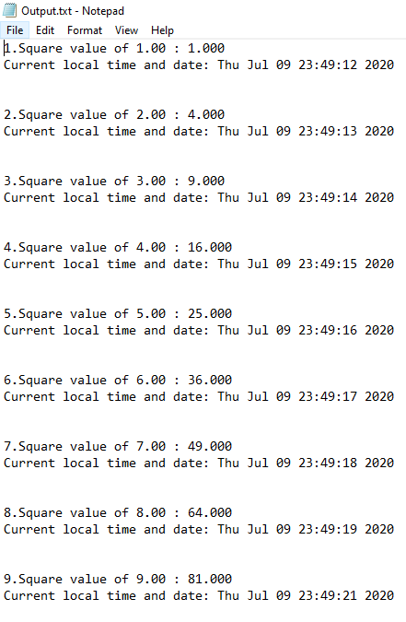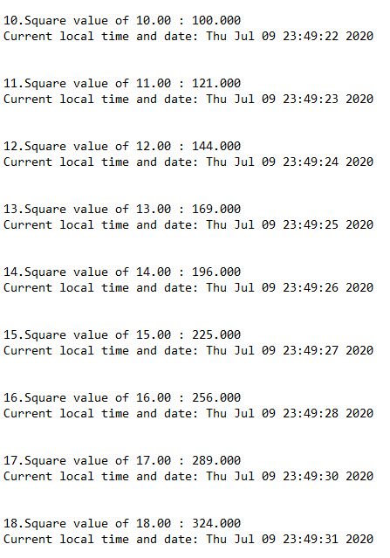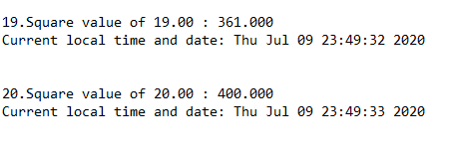

**Saved Text Files**

**Discussion And Knowledge That You Have Achieved**

* Can be improve my C language coding knowledge.
* How to do coding program including mac address, name etc.
* How to get the square value of any given number by the user, print the given number and square value of the number in front of the given number with the system time.
* Can be improve the above program to write above information in to a textfile.

**Submission Date And Time**

**12th July 2020 – 4.00 P.M.**